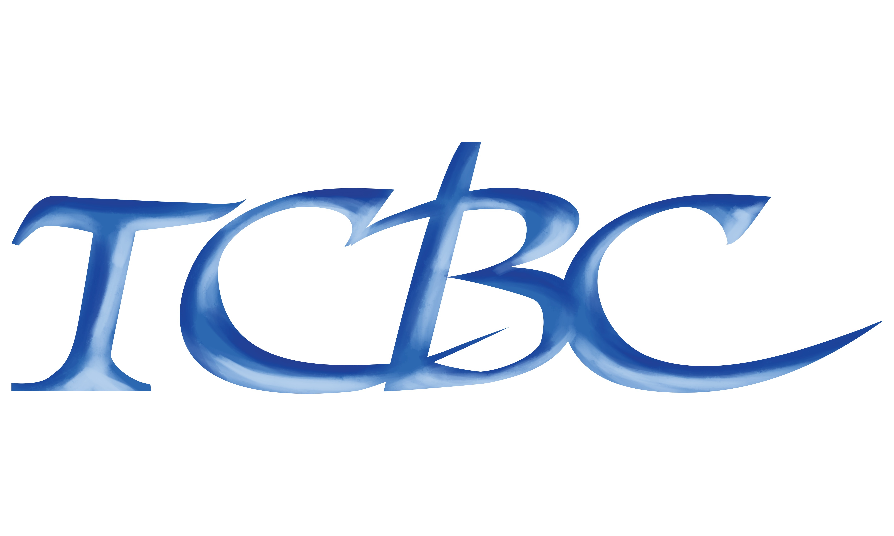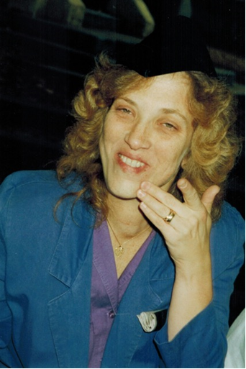

TCB Council Offers Academic Scholarships through the Marianne Bosley Memorial Scholarship Fund
The TCB Council, in memory of Marianne T. Bosley, a long-time colleague of the FCC/TCB community, who passed away in June 2014, has created the Marianne Bosley Memorial Scholarship Fund. Those of us who had the privilege of working with Marianne know her constant striving for quality and knowledge. It is in that light that we seek to pass on her legacy to the next generation.
Finding and keeping qualified technical personnel is a constant challenge for our industry. To encourage future generations of skilled employees, The TCB Council annually offers individual awards of up to $5000, totaling up to $20,000 in academic scholarships to students planning scientific or engineering careers. The Scholarships are available to all direct family members of the current TCB Council membership as documented on the TCB Council website (www.tcbcouncil.org).
Candidates must be a senior in High School or currently matriculating at bachelor-degree granting institutions or graduate programs within the United States, and must also major in the physical sciences practiced by TCB Council members: physics, chemistry, engineering, or related STEM curriculum.
Scholarship awards are based on the applicant’s academic achievement, career goals, leadership and financial need. Completed applications must be received in the TCB Council office between February 1 – April 1. Included with the application, you must provide the following:
- Completed Application Form (from page 2)
- Resume outlining activities in high school and college including field of study
- 300-500 word essay on education goals and future plans
- Two letters of recommendation from their school’s current STEM faculty
- A transcript of your grades
Incomplete Applications will not be considered.
TCB Council only considers the first 20 completed applications received. Successful applicants will be notified by June 1st (recipients will also be posted on the TCB Council website at that time). Award monies will be sent directly to the school, not to individuals.
Completed applications and all enclosures should be mailed or emailed to:
TCB Council, Inc.
264 Dey Dr.
Harpers Ferry, WV 25425
Tel: (443) 622-3300
www.tcbcouncil.org
Email admin@tcbcouncil.org

SCHOLARSHIP APPLICATION (DEADLINE: April 1)
Student (applicant) Name and E-mail

Home Address City, State, Zip and Tel.

Current School/Grade or Level

TCB Council Member Company, Sponsors Name and relation to applicant

College/University and department/office to which award should be sent

University Address City, State, Zip Tel.

Intended Course of Study/degree

Expected Graduation Date

